1. Create a Redshift data warehouse.

2. Using the query editor

: a. Load some data

b. Query the data

1. Create a Redshift data warehouse.

## Go to amazon redshift > [Redshift Serverless](https://us-east-1.console.aws.amazon.com/redshiftv2/home?region=us-east-1#/serverless-setup)

## Get started with Amazon Redshift Serverless

## Configuration > Customize settings

## Namespace > Target namespace (redshiftdemo)

## Admin user name (admin)

## Admin password > Manually add the admin password(_)

## Associated IAM roles > Create the default IAM role > Any S3 bucket

## Rest all default and create

## 

## 

**2. Using the query editor**

**a. Load some data**

**b. Query the data**

a. Load some data

to load date create s3 bucket and add object ( sample data)

s3 bucket name (9945919798)

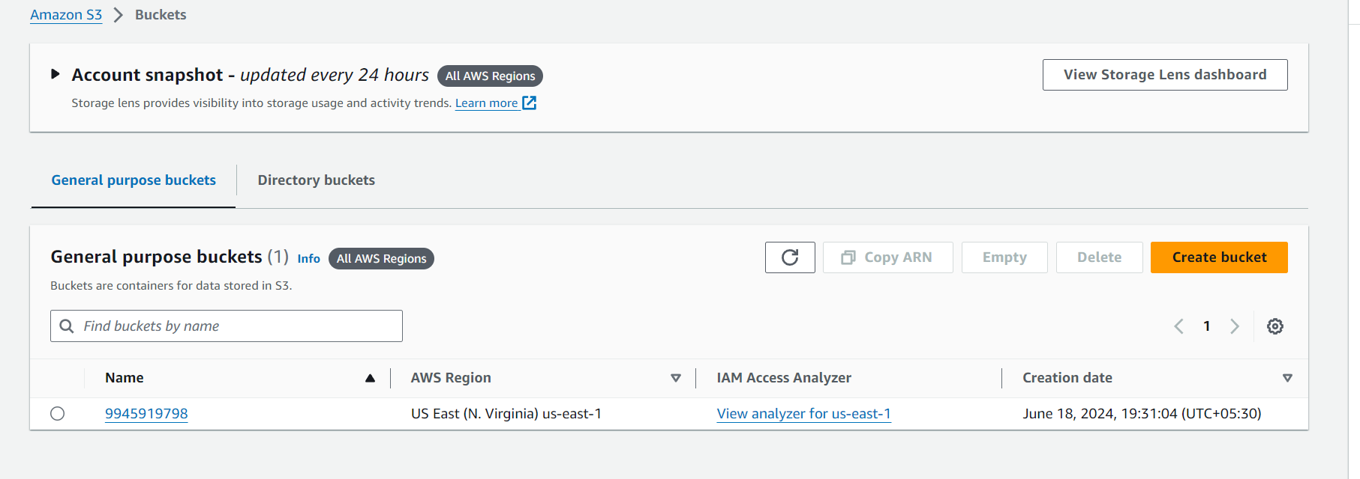

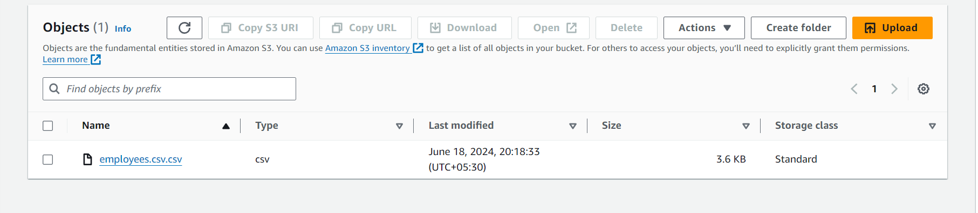

To load data using S3

* go to query editor > Load data
* Data source > Load from S3 bucket > select s3 URL and select sample data file (browse )
* Rest default > next
* Table option > Load new table
* Cluster or workgroup > select serverless redshift
* Database > dev
* Schema >public
* Table > employee_table
* IAM role > select IAM role which created while creating where house > create table
* Load data

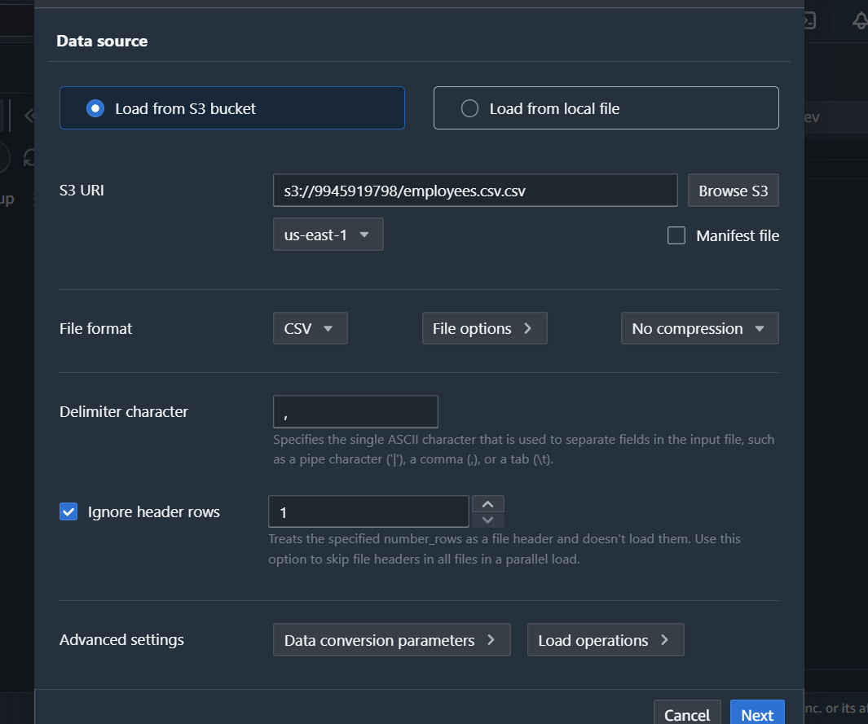

Create table

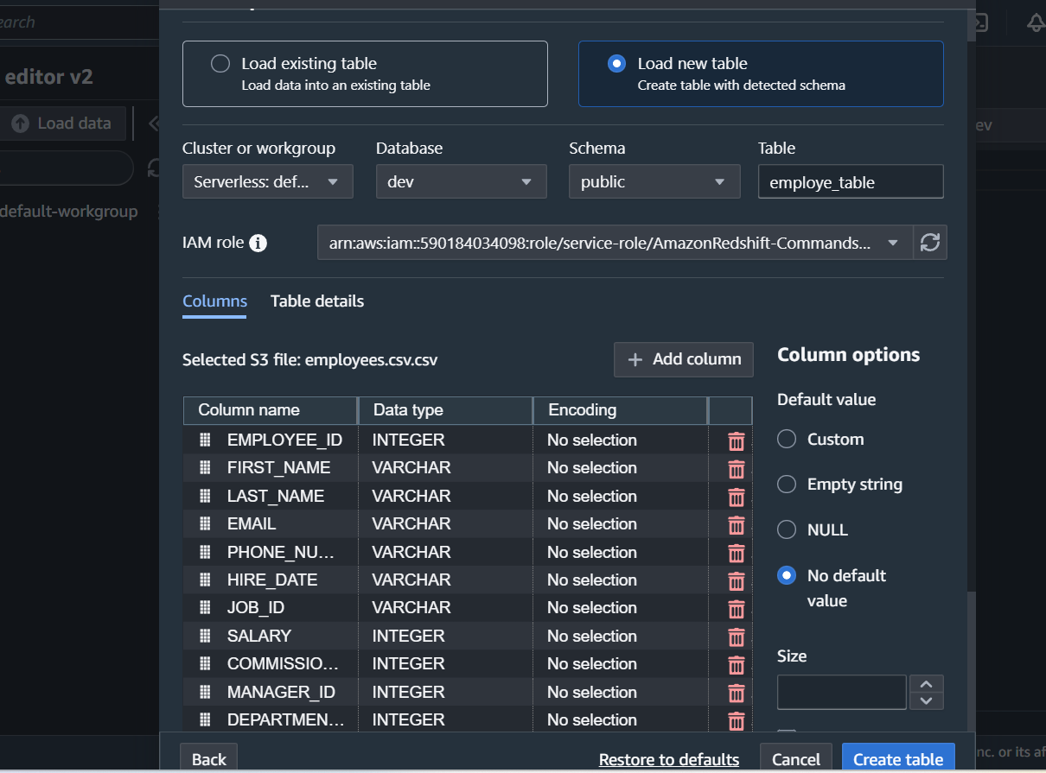

Load data

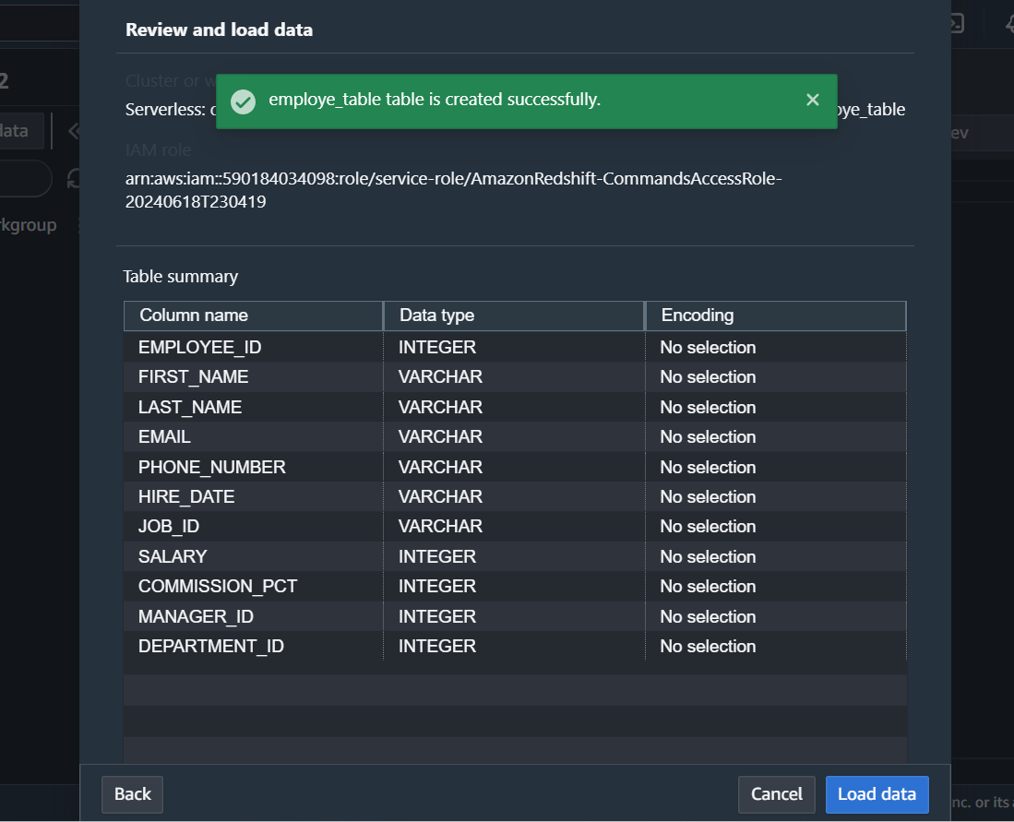

B. Query the data

To query data > run this

COPY dev.public.emp_table FROM 's3://9945919798/employees.csv.csv' IAM_ROLE 'arn:aws:iam::590184034098:role/service-role/AmazonRedshift-CommandsAccessRole-20240618T230419' FORMAT AS CSV DELIMITER ',' QUOTE '"' IGNOREHEADER 1 REGION AS 'us-east-1'

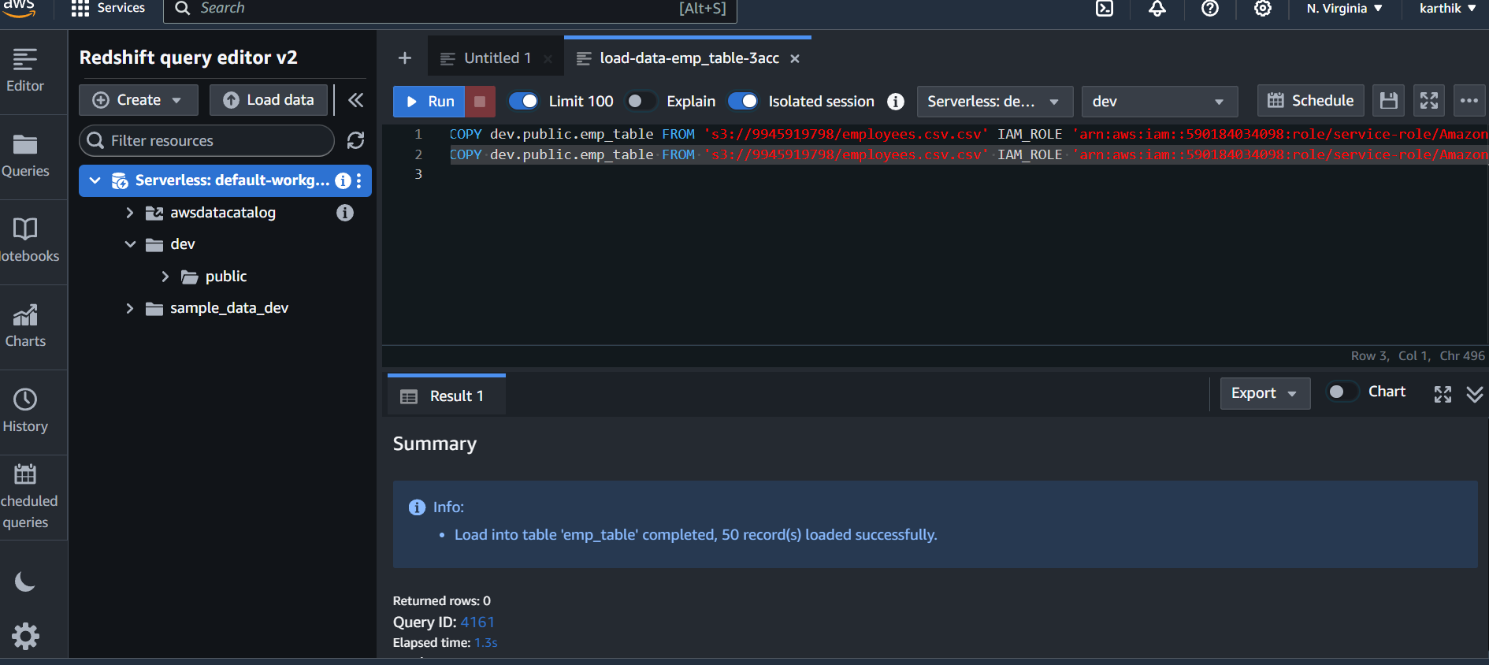

And

Select * from dev.public.emp_table ( table name )

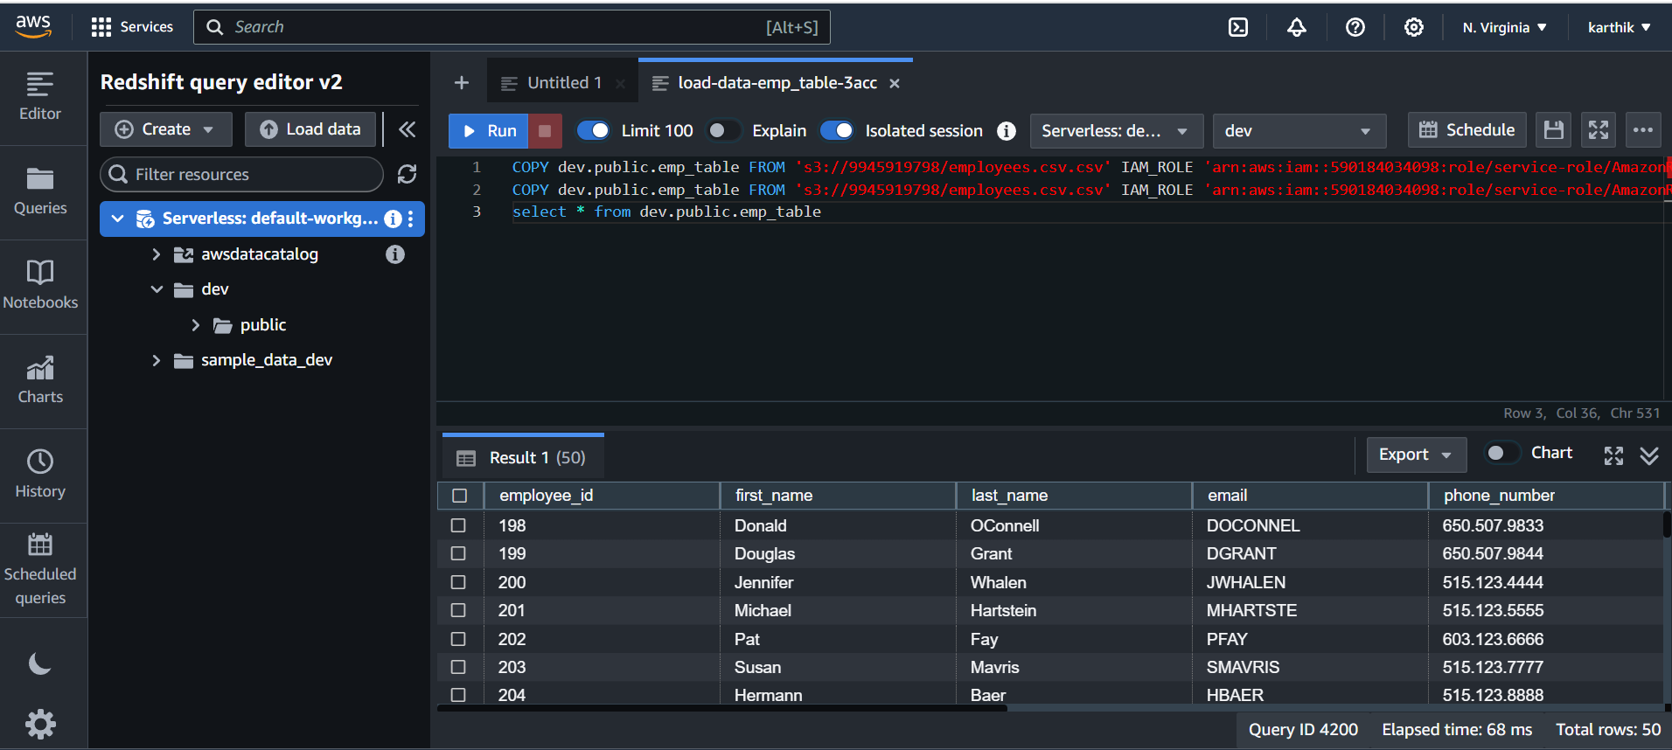

## Load data

#### Table options